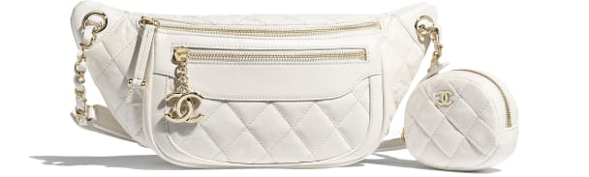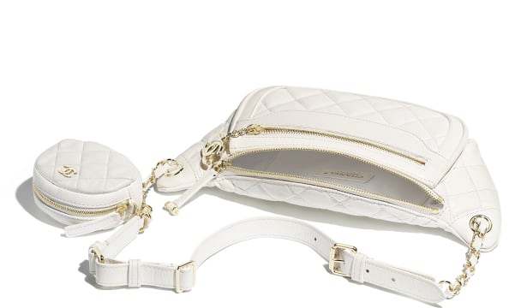

CHANEL-Waist Bag & Coin Purse

CAN$3,625

COLOR : White  
SIZE : ONE SIZE  
IN STOCK

[Detail](http://127.0.0.1:60314/content/X-oI_6yUCM3NGjYoAAAR/kyi18X0/wdogZxr/XrA2wmb/kriv6Nv" \l "collapse)

Aged Calfskin & Gold-Tone Metal

• 15 × 34 × 6 cm

• Reference: AS1077 B01401 10601

[CARE & COMPOSITION](http://127.0.0.1:60314/content/X-oI_6yUCM3NGjYoAAAR/kyi18X0/wdogZxr/XrA2wmb/kriv6Nv#collapse1)

• Leather

• Imported